  Maranatha Bible College
  Continuing to change the world with the Gospel: New Churches, New Growth
  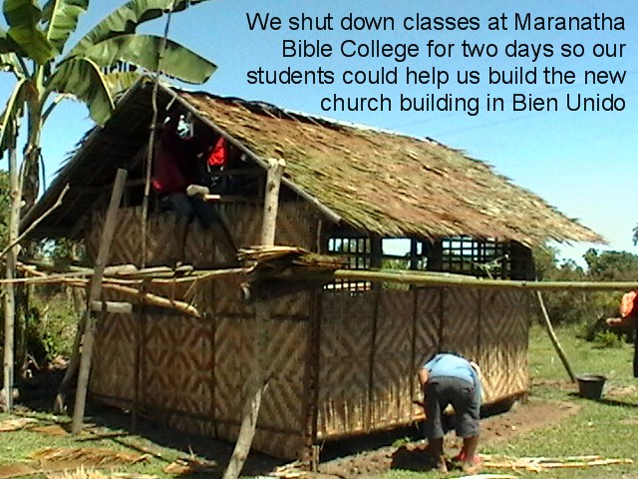
  The bulk of our soul-winning on Bohol happens through Maranatha Bible College. This month we opened a new church in Liberty Bien Unido, a small farming and fishing community about six miles from the college. We’ve personally been working there since September. It’s a unique place in that people in other areas typically tell us they’re glad to go to our Bible studies but they’d never attend a church service—that would be turning their back on their culture and heritage. In Liberty, however, many people said they wouldn’t attend our Bible studies, but would gladly go to a church service if we had one. Thanks to a special gift from a family in America we were able to buy land and build a meeting place. The first week 65 people attended worship! We’re placing Ricky Yungod, one of our first MBC graduates, in charge of this new congregation.
  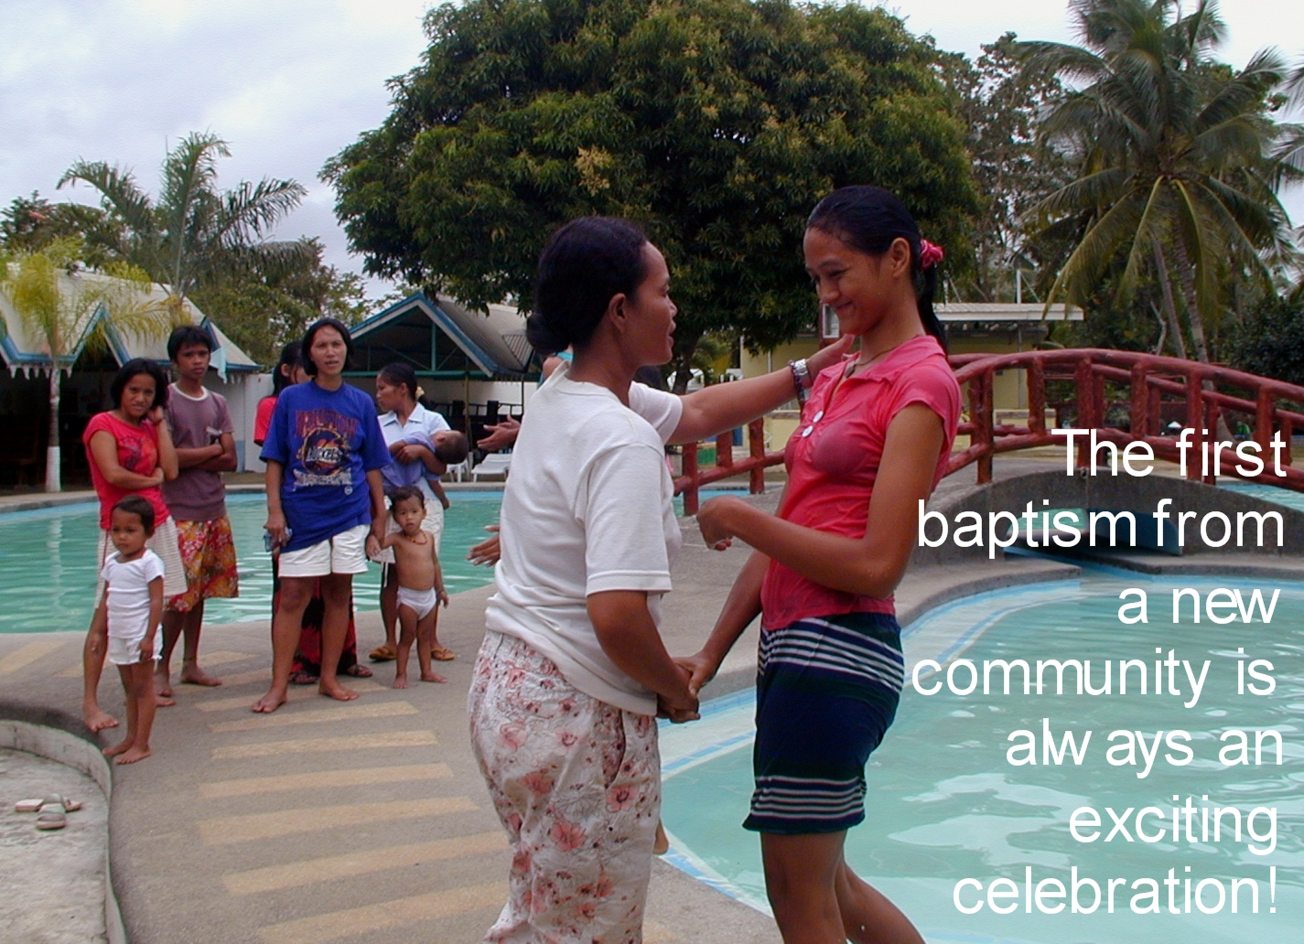
  For several months Jean’s been teaching a group of women in Kaigsaonan. Although several there have come to believe in God over the last year none were willing to be baptized. Culturally, to do so is tantamount to leaving the old ways, the family traditions, and the values and beliefs of the community. It was only at the end of January when someone finally said, “I believe and I will obey” and stepped forward into the waters of baptism. We believe the dam has finally been broken and soon many more will follow forward in their new faith!
  We’ve designed Maranatha Bible College to train and equip Filipinos to reach out to their own people with the Gospel. All students are involved in weekend community outreaches, with the goal of starting new churches in un-churched areas. A monthly gift of $25 makes a significant contribution towards starting new churches and saving souls.
  We Want to Hear from You!
  Do you like the new newsletter format? Take our survey at http://www.kingdomadvetures.org/polls/
  Until March 29th you can call us at 909-510-9612. Or, email anytime: mike@kingdomadventures.org
  Want to be kept up-to-date on our U. S. activities and speaking engagements? Send a blank email to schedule@kingdomadventures.org to receive email updates of when and where Mike and Jean will be.
  Join the KAIM Boxing Club!
  While in America we collect supplies and materials for ministry. We need new and used items for boxing, and people to sponsor the cost to ship the boxes!
  We are prioritizing kitchen items (for VOH families of 12!), mechanics’ tools, computers (for the new VOH homes and office, as well as the MBC library), and, with new homes and churches opening, we’re always looking for digital cameras and cell phones.
  Each box costs $75 to ship. Your gift above and beyond your regular giving helps much needed supplies get to the field.
  Safety and Filipino Politics
  Several people have asked intelligent questions regarding stability and safety in the Philippines.
  Q: In the pictures Village of Hope looks like an amazing place! Is there any risk of the government seizing it to exploit its value? I’ve heard of such things happening.
  A: No. Perhaps more so than any land-owner in the same area as Village of Hope, we’ve created a very thick paper trail in several government offices showing proper legal ownership of VoH’s land.
  Q: Recently on the news a group of Red Cross workers was taken hostage in the Philippines. How safe is it for you to work there? How safe is it for short-term missionaries who join you for a few weeks or months?
  A: It is very unfortunate what happened with the Red Cross relief workers, and they need prayer. They were working in Mindanao, a province much further south than Bohol. In fact, the majority of internationals taken hostage in recent history were taken by terrorist groups based in Mindanao. I can’t think of any extremist group taking hostages, foreign or otherwise, on Bohol. Even if there were danger always remember there is no safer place to be than the center of God’s will!

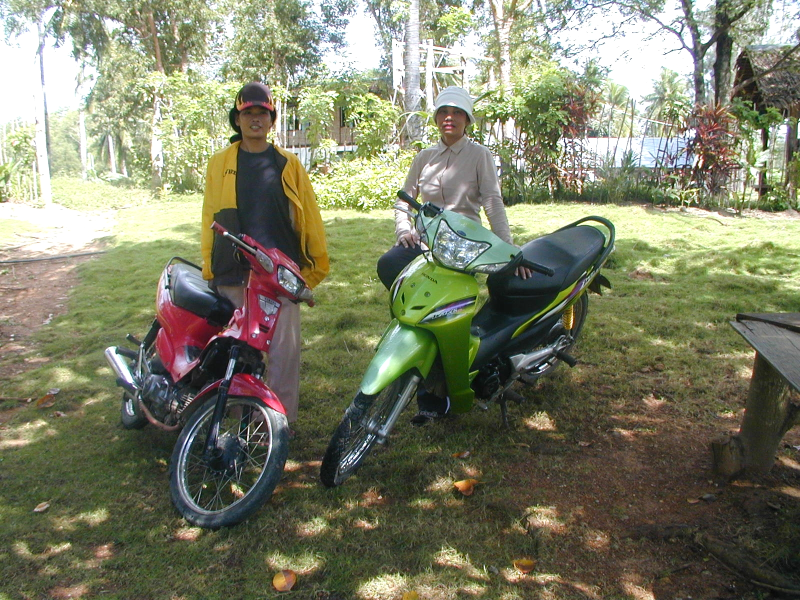
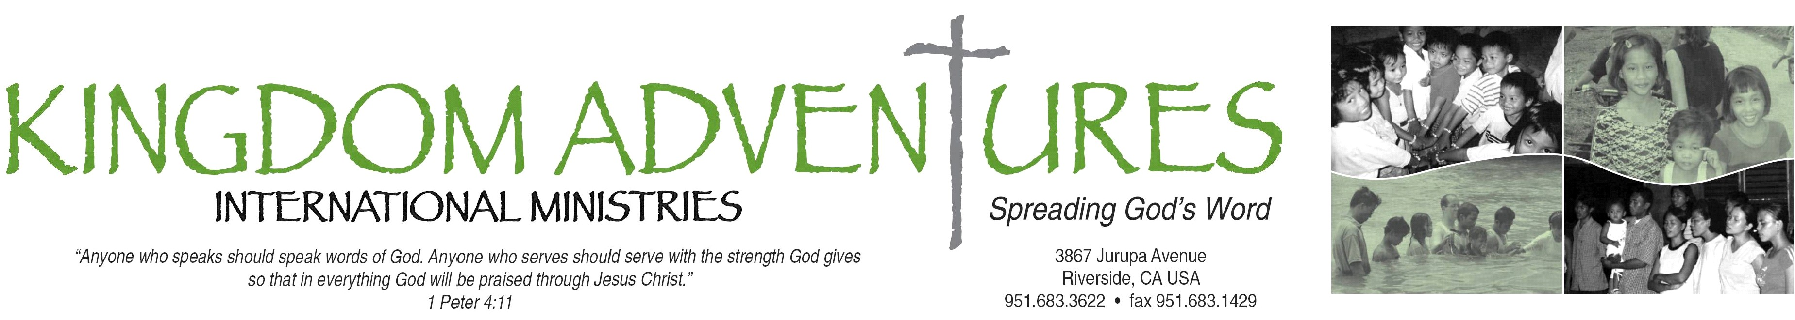

February 2009

Dear Friends,
January was quite a month! By far it was our most challenging month of ministry ever, but through it God showed us some amazing victories and taught valuable lessons! In January we saw souls won from new communities, opened a new church, and discovered new skills and potential in the Filipino ministry team we’ve been training.
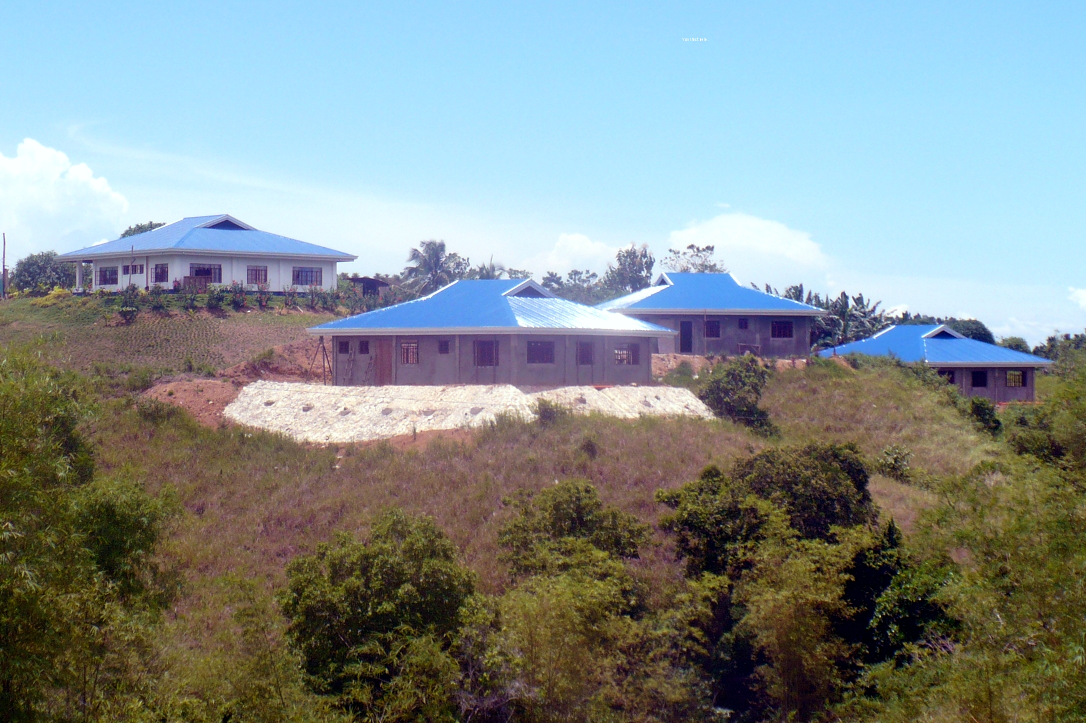
This month we also spent a lot of time making plans for Village of Hope. We’re positioning ourselves to move House Parents into Home 2 in April (and Kids in May), so, all the last-step, fine detail things had to be checked to make sure the Home will be ready; there’s still a little more work to be done on the Home. When we return to the Philippines on April 1^{st,} we’ll be excited to step forward into this new phase of ministry!
By the time you get this we’ll be in America! We’ll have six weeks to visit family and friends. It’ll also be a time of speaking at several new churches and groups about what God is doing on the island of Bohol. Please keep us and our travels in your prayers.
Speaking of prayer, we want to thank everyone who’s shared their prayer requests with us. Every staff and student meeting we hold in Bohol includes prayer for our ministry partners in America. Consider this another very public request for you to share your prayer needs with us! It’s amazing to us when a Bible college student approaches us to ask how someone is doing that we prayed for months earlier at class or student meeting. And, of course, your prayers are invaluable to us, too!
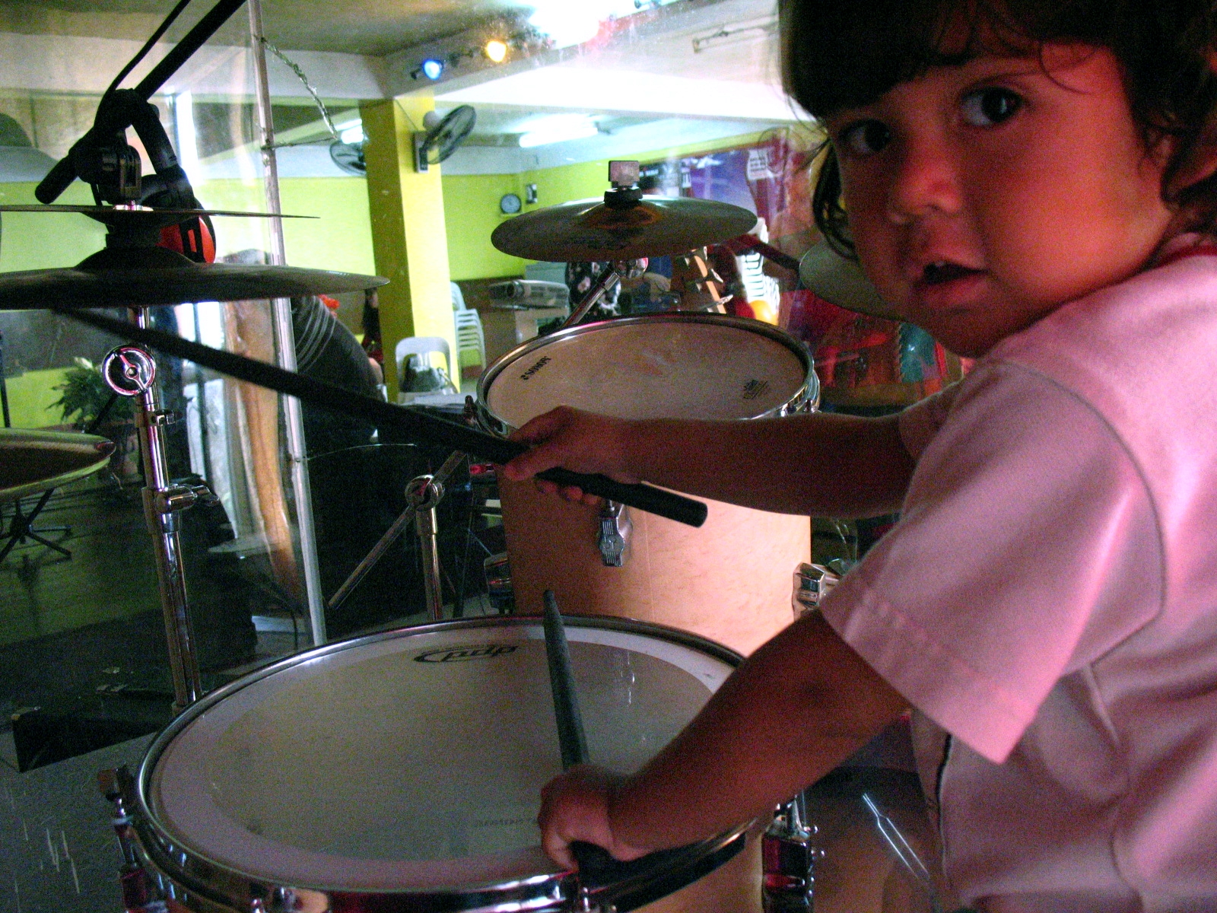
January was a challenging month, but it resulted in souls being won, another new church being built, Homes being closer to care for lost and hurting children, and our own relationship with God moving to a deeper level. January was a very good month, and we couldn’t have done it—we couldn’t have survived it!—without your friendship, your prayers, and your continuing financial support. Thank you for being a part of our lives and this ministry!
 Your missionaries,

Mike and Jean and Baby Luke

Many friends in southern California held a garage sale to raise funds for two bikes for our outreach teams! Thank you so much!
Home 2, targeted for occupancy in April 2009!

THE ANNUAL LUNCHEON IS BACK!

On March 29th, after a year of hiatus we’ll be resuming our annual sponsorship luncheons! If you’re in the southern California are be sure to keep your calendar free, and watch for your invitation in the mail!

PHOTO OF MONDAY NIGHT OUTREACH MEATING.

